RISCV CPU Documentation Notes

Installation Instructions
we should set environment variable $RISCV to the –prefix we want (currently /mnt/d/riscv/$tool/ where $tool=gcc-rv32i)
If we already have it built from a previous installation, add this to ~/.profile
WARNING – on a new system, don’t forget to install dependencies shown below – texinfo and gperf don’t seem to be available on APT any more but they don’t appear to be important
# set PATH to include RISCV toolchain if it exists if [ -d "mnt/d/riscv/gcc-rv32i" ] ; then RISCV="mnt/d/riscv/gcc-rv32i" fi if [ -n "$RISCV" ]; then PATH="$RISCV/bin:$PATH" fi
# Add elf2hex to the Path too if [ -d "$RISCV/../elf2hex-1.0.1" ] ; then PATH="$RISCV/../elf2hex-1.0.1:$PATH" fi

RISC-V GNU Compiler Toolchain installation
Using Ubuntu (bash) via Windows Subsystem for Linux
# get the source files from github
git clone --recursive https://github.com/riscv/riscv-gnu-toolchain

# install build process dependencies
sudo apt-get install autoconf automake autotools-dev curl python3 libmpc-dev libmpfr-dev libgmp-dev gawk build-essential bison flex texinfo gperf libtool patchutils bc zlib1g-dev libexpat-dev

# configure MAKE and build Newlib cross-compiler (for embedded)
./configure --prefix=/opt/riscv/rv32i --with-arch=rv32i --with-abi=ilp32
make -j4

Note:
see ./configure –help for more build options
change -prefix to change the install directory -use $RISCV

from the built directory (/mnt/d /riscv/rv23i/bin) you clsan now run ./riscv32-unknown-elf-gcc to compile stuff

Using the Toolchain
Compiling a source file:
riscv32-unknown-elf-gcc hello.c -march=rv32i -mabi=ilp32 -o a.out
Getting the assembly from the compiled products:
riscv32-unknown-elf-objdump input_elf -d > output.asm
Getting Verilog Memory files with address offsets etc
riscv64-unknown-elf-objcopy -O verilog input_file output_file

Building raw hex for VHDL memory data for programs we use elf2hex to convert the ELF file produced by riscv32-unknown-elf-gcc into a hex file https://github.com/sifive/elf2hex:
elf2hex --bit-width 32 --input a.out --output a.hex

Extra GCC arguments
We get a lot of other stuff generated by GCC beyond our Main function:
00010074 <register_fini>:
00010090 <_start>:
000100dc <__do_global_dtors_aux>:
0001012c <frame_dummy>:
00010150 <main>:
00010170 <exit>:
000101a0 <__libc_init_array>:
0001023c <memset>:
00010318 <__call_exitprocs>:
00010438 <atexit>:
0001044c <__libc_fini_array>:
000104a8 <__register_exitproc>:
00010540 <_exit>:
00010584 <__errno>:
We can use the following gcc arguments to change what is generated:
-nostartfiles If we use this, we must provide our own crt.s (C runtime)
-nostdlib This removes all the cruft and just leaves us with <main>

Linker Notes
We can pass different arguments to the linker (by default gcc will link as well unless we pass it -c for compile only)
https://twilco.github.io/riscv-from-scratch/2019/04/27/riscv-from-scratch-2.html
This site nicely goes into how to set up a custom linker script to set our memory regions.

Memory Map
See “Memory Map.ods”.
The trouble we have with a separate program and data memory
We need to decide between a separate program and data memory (requiring program ROM, data ROM, data RAM, or store RO data in RAM for 2 memories)
Or alternatively (as we currently have), store RO data in the program memory and only differentiate by type. This would require the ROM to be on the same memory mapped bus as the RAM and the rest of the system, reducing performance. We could always use the ROM as a dual-port memory, with a hard connection direct to the processor.

ISA Notes
We will be targeting the base integer ISA ‘RV32I’ (RISC V, 32-bit, Integer)
We will not support Variable Length instruction encoding (at this time)
Support for hardware multiply and software divide (ISA extension ‘M’) may be added later
This minimal RV32I Instruction Set has only 40 instructions, although check to see if we really need ECALL/EBREAK instructions (system calls?)

Instruction Formats
7 |  |  | 5 |  |  | 5 |  |  | 3 |  |  | 5 |  |  | 7 |  |  | Length
31 |  | 25 | 24 |  | 20 | 19 |  | 15 | 14 |  | 12 | 11 |  | 7 | 6 |  | 0 | Position
Funct7 |  |  | Rs2 |  |  | Rs1 |  |  | Funct3 |  |  | Rd |  |  | Opcode |  |  | R Type
Imm[11:0] |  |  |  |  |  | Rs1 |  |  | Funct3 |  |  | Rd |  |  | Opcode |  |  | I type
Imm[11:5] |  |  | Rs2 |  |  | Rs1 |  |  | Funct3 |  |  | Imm[4:0] |  |  | Opcode |  |  | S type
Imm[31:12] (20 bits) |  |  |  |  |  |  |  |  |  |  |  | Rd |  |  | opcode |  |  | U type

There are 2 other variant formats (B and J) that provide other ways of handling Immediates. See page 16 of the ISA spec for more details.
B and S, and format instructions are very similar, with B and J instructions used for multiples-of-2 immediates (like addresses). The difference is how the immediates are decoded out of the instructions (see Fig 2.4 below)
Sign extensions are always performed using bit31 of an instruction.
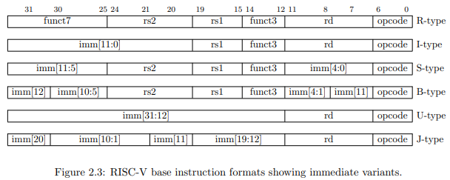
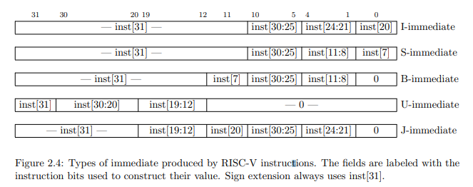

Integer Computation Instructions
Use either I-type (register-immediate) or R-type (register-register) instructions, with rd as the destination register.

Integer Register-Immediate Instructions

Control Transfer Instructions

Load and Store Instructions

Memory Ordering Instructions

Environment Call and Breakpoints

Implementation Notes
Memory Mapping – memory address overflow happens in a circular way

Registers
There are 32 32-bit registers x0 – x31. x0 is hardwired to 32b0 and the other 31 registers are general purpose.
The program counter pc holds the address of the current instruction and is separate from the compute registers
Convention states that register x1 is the Return Address of a called function, with x5 available as an alternate link register. Convention also states that x2 is the Stack Pointer.
We may wish to add extra hardware to accelerate function calls using x1 and x5 (see JAL and JALR)

Full RV32I Instruction listing
